# CS 255 System Design Document

## UML Diagrams

### UML Use Case Diagram

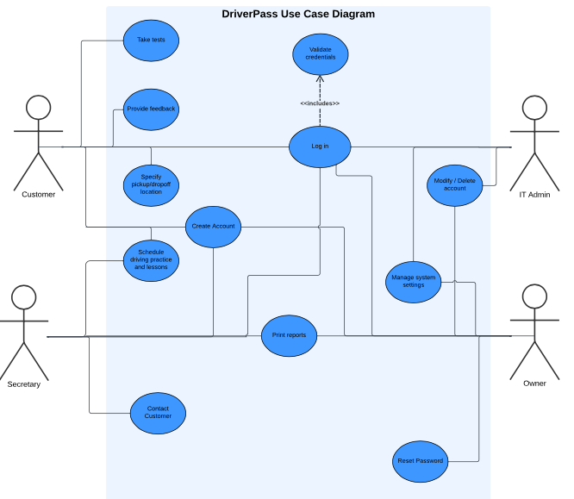

### UML Activity Diagrams

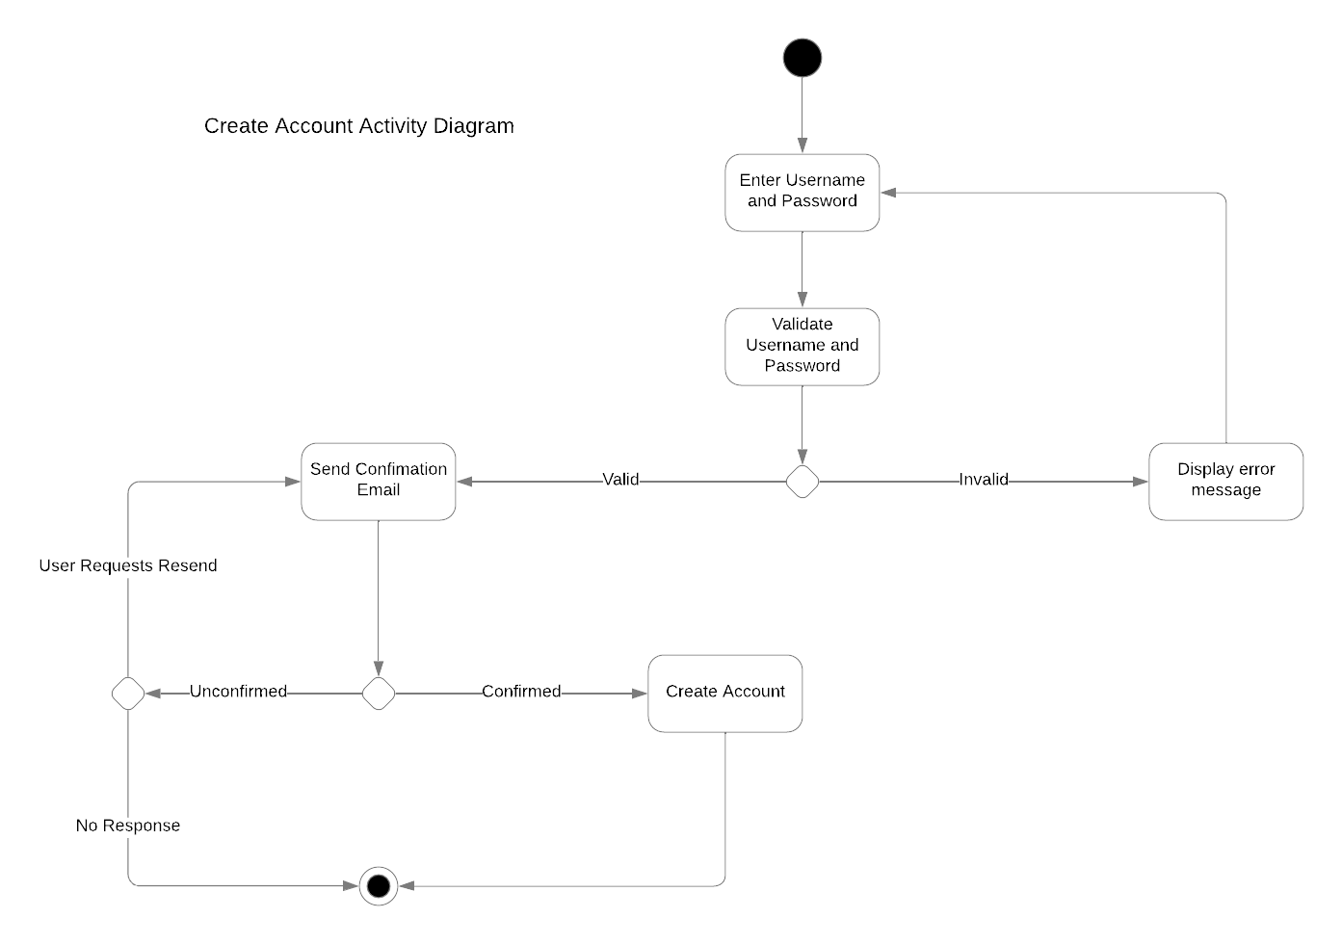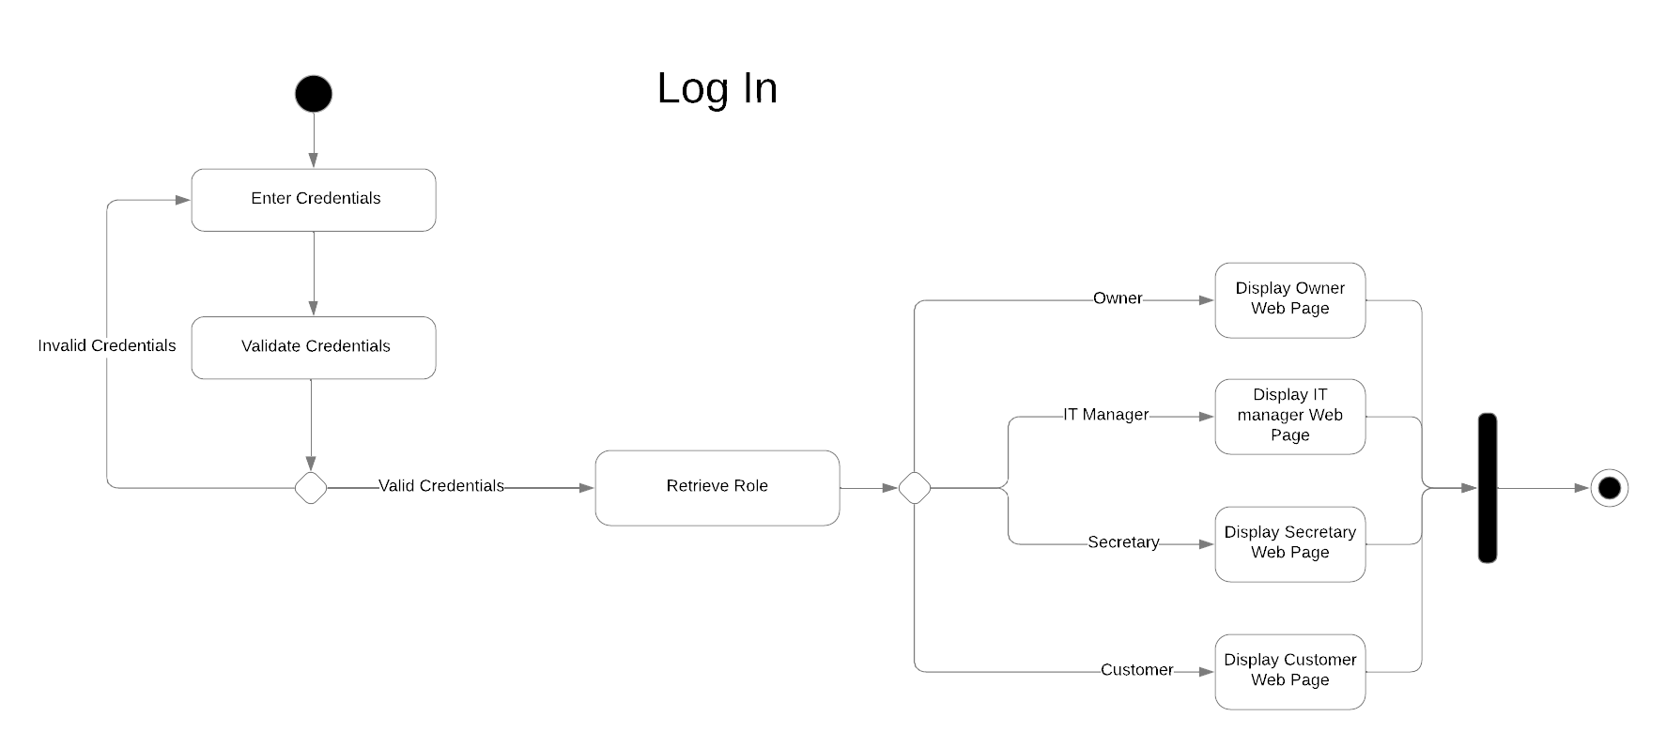

### UML Sequence Diagram

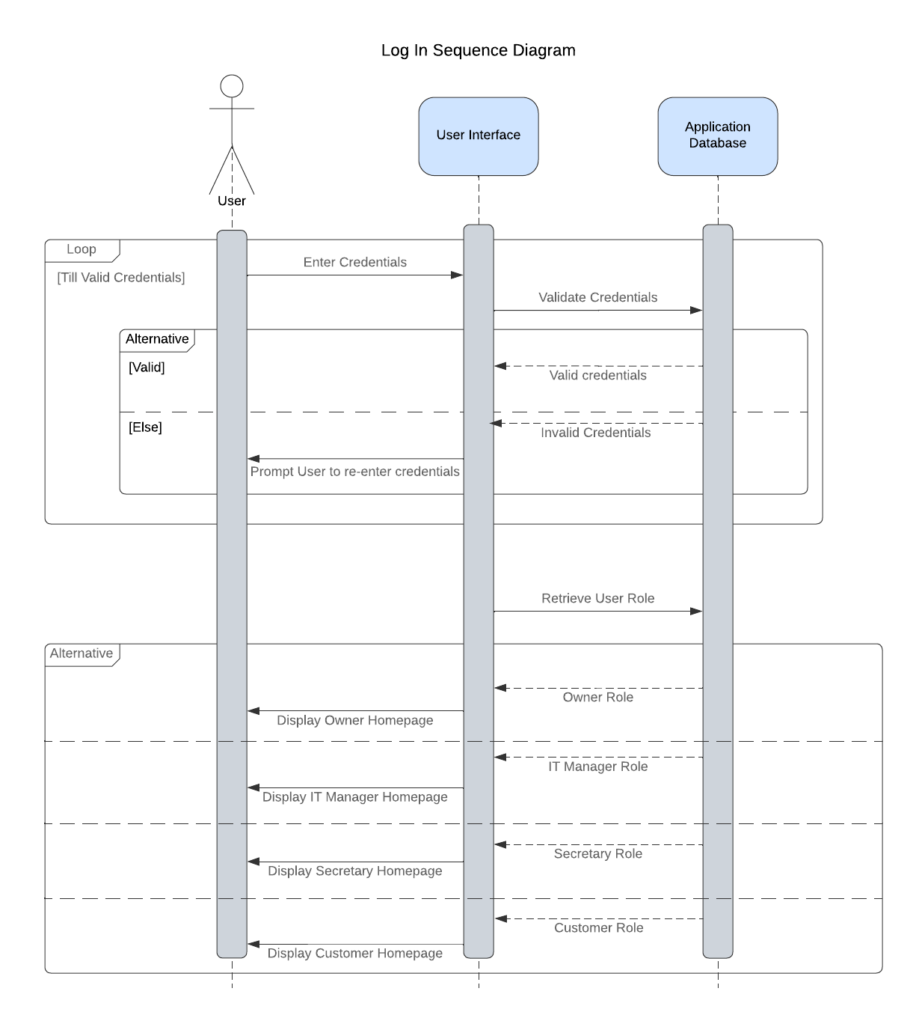

### UML Class Diagram

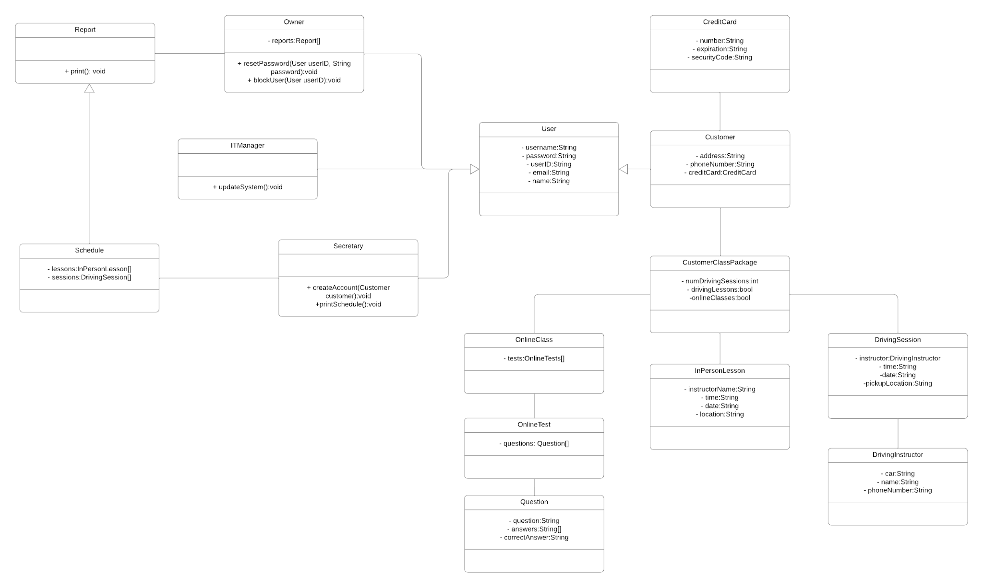

## Technical Requirements

Hardware

The system that we are designing does not necessarily require any extra hardware outside of a normal business computer. The system is based on a web-based application so any device that can access the internet will be capable of utilizing the system.

Software

* RESTful API utilizing secure communications between client/server
* Up-to-date software to ensure maximum security
* Secure and up-to-date third-party services/applications being utilized i.e. databases, scheduling
* Compatible with top browsers

Other

* GDPR compliant
* PCI DSS compliant